13. Implementing database security measures (e.g. user authentication, access control).
USE test;
CREATE TABLE employee5(
id INT AUTO_INCREMENT PRIMARY KEY,
name VARCHAR(100),
email VARCHAR(100),
salary DECIMAL(10,2)
);
--2 Create Users (Authenticatio)
CREATE USER IF NOT EXISTS 'readonly_user'@'lacalhost'
IDENTIFIED BY 'ReadOnly@123';
--Read/Writer User
CREATE USER IF NOT EXISTS 'write_user'@'locathost'
IDENTIFIED BY 'Writer@123';
--Admin User (for this DB only)
CREATE USER IF NOT EXISTS 'db_admin'@'localhost'
IDENTIFIED BY 'Admin@123';
--3. Grant Privileges(Access Control)
-- Grant SELECT only to readonly_user
GRANT SELECT
ON secure_db.*
TO 'readonly_users'@'lacalhost';
--Grant SELECT,INSERT,UPDATE,DELETE to writer_user
GRANT SELECT, INSERT, UPDATE, DELETE
ON secure_db.*
TO 'write_users'@'locathost';
--Grant ALL privileges (but only for this DB )to db_admin
GRANT ALL PRIVILEGES
ON secure_db.*
TO 'db_admins'@'localhost';
--Apply privileges
FLUSH PRIVILEGES;
--4.Check Privileges (Optional Audit)
--Check all users
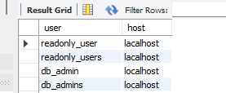
--Check privileges for each user
SHOW GRANTS FOR 'readonly_user'@'localhost';
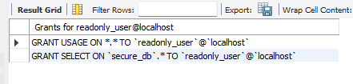
SHOW GRANTS FOR 'write_users'@'locathost';
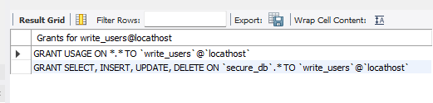
SHOW GRANTS FOR 'db_admin'@'localhost';
